

**A Mini -Project Report**

**On**

**“AID FOR BLIND”**

**Python**

**Submitted by**

**P.PRAVEEN KUMAR (19B21A04B9)**

**R.MOUNIKA (19JN1A0439)**

**P.JAHNAVI SAI (19B21A0409)**

**D.JAYANTHI (19B21A0445)**

**N.PAVANI (19JN1A0501)**

**Departments**

**Electronics and Communication Engineering and Computer Science Engineering.**

**Submitted to**

**Dr.Krish Naik**

**Chief Innovation Officer**

**Submission Date: December 19,2021**

**INDEX**

ABSTRACT

LIST OF ABBREVATIONS

INTRODUCTION

AIM

OBJECTIVE

TECHNOLOGIES USED

MODULES

SYSTEM REQUIREMENTS

CODE

HARDWARE COMPONENTS

STEPS INVOLVED

OBSERVATIONS

ADVANTAGES

SOLUTION

CONCLUSION

**ABSTRACT**

This report represents the mini-project taken by our group of 5 students for the partial fulfilment of “AID FOR BLIND”, python. It is vital that many people are unable to see the world due to many problems those may be retinal problems, inheritance or due to some accidents. Such problems can be tackled with Python and its importance, along with many other languages and cannot be overstated. This project intends to illustrate the model that includes both software and hardware.

This model is then used for blind people to see clearly as information is passed directly through neurons in brain. In this process, we have focused on the hardware components which are used mostly and the amount of power and current required and should be given to brain directly.

Keywords— Neurons, Hardware components

**LIST OF ABBREVATIONS**

CV – Computer Vision

Mp – Micro Processor

**INTRODUCTION**

The main aim of the project is to implant artificial eyes to the blind people.

Here comes the biggest question, **Why humans can't see?** There are 6 major reasons

1.Diabetic retinopaths

2.Age-related.

3.Glaucome.

4.Eye Injury.

5.Born defect in eye ball.

6.Inheritance

Most common thing in all of them is they all have photo receptors which is 100 million rods and 6 million cones and visual cortex but due to some damages in external layer of eye they can't see.

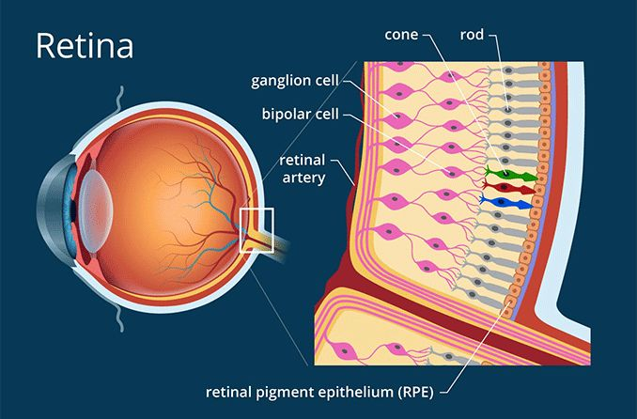

**AIM**

Aim is to make blind people to explore world with their eyes. For this we have to design a perfect model with both software and hardware components.

**OBJECTIVE**

India has the largest share of the world's blind? The estimated size of the severely vision impaired Indians is 1 crore (10 million) persons. Added to this are another 1 crore persons who are Low Vision (moderately vision impaired who too are disabled to work and live like normal sighted people).

“**We can't remove the visual impairment, but we can remove the disability caused by it.”** Based on the research of past 10 years most of the people were unable to see due to the defect in retina layer even their remaining organs in eye are functioning well so to overcome that we came with a solution.

**TECHNOLOGIES USED**

Python

Embedded Technology

Communications

Signal and Systems

Microchip Technology

**MODULES**

Computer Vision (CV2)

**SYSTEM REQUIREMENTS**

**Hardware Requirements:**

RAM: 4GB and higher

Processor: Intel I3 and above

Hard Disk: 500GB: Minimum

**Software Requirements**:

OS: Windows or Linux

Python IDE: Python 2.7 and above

Jupyter notebook

Setup Tools and pip to be installed for 3.6 and above

Language: Python

**CODE**

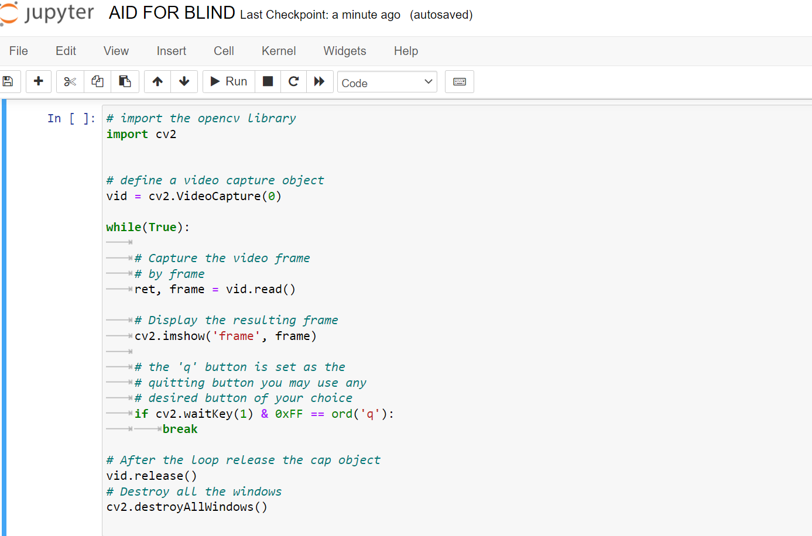

This is coded as software to the camera which we insert in to blind people as third eye which captures everything infront of them when the certain amount of current is provided.

This code interms helps us to capture the video which will be in mp4 format.

**HARDWARE COMPONENETS**

1. Camera

2.Memory – for storage purpose

3.Transmitter

4.Reciever

5.Band Pass Filter (BPF)

6.Microprocessor

7.Encoder

8.Decoder

9.Power Amplifier

10.Low Pass Filter.

**THEORY**

The video that is recorded in camera which is inserted as third eye for blind person should be encoded to digital signal (1’s and 0’s) and then we should remove unwanted noise by using low pass filter and band pass filter and also should maintain current balance by using power amplifier(since microchip is connected to neurons directly we should not give more current for this process and that digital signal should be again converted to original video in mp4 format.

**STEPS INVOLVED :**

1. Firstly, we have to record video through camera that is inserted.
2. Then we have to store or save video in mp4 format.
3. CONVERSION OF MP4 SIGNAL TO DIGITAL SIGNAL:

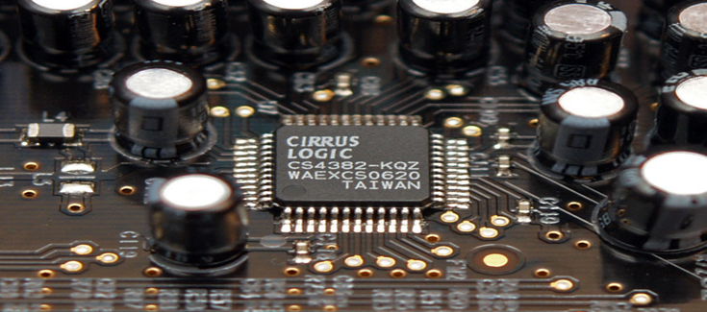

By using this circuit we can convert AC video signal to DC signal i.e signal in the form of electrical signal.

**(4)** TRASMISSION

These digital signals should be passed to next level i.e to encoder.

1. ENCODER:

Encoder converts this signal to digital signal.

1. LOW PASS FILTER:

Low Pass Filter is used to remove unwanted noise and modify signal.

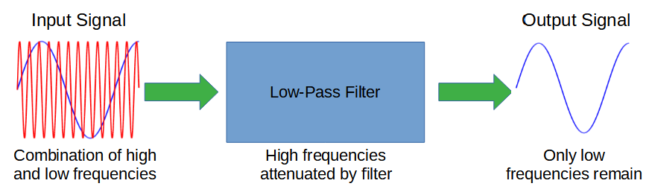

Now unwanted noise with high frequencies are removed and only wanted signals will be passed.

1. MICROPROCESSOR

Microprocessor is a chip which is connected to neurons in brain of blind people.So that the info i.e video signal will be passed to microchip.

**KinetisKL02** the smallest microprocessor which is involved in this process and designed to perform Quantization when neuron is in resting position with 0.07 milli volts .

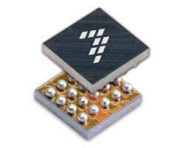

Size of it is very small i.e just **1.9 x 2.0 mm**. Measuring, the Kinetis KL02 MCU is 25 percent smaller than the industry's next-smallest ARM® MCU.

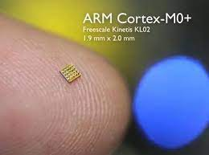

1. PUSHING THAT CLUSTERS INTO VISUAL CORTEX:

After Quantization the whole signal will be pushed to nerves to visual cortex.

1. VISUAL COREX DETECTS SIGNALS: the visual cortex detects

signals and forms a view to the human

1. MAN WILL IDENTIFY CLEARLY: The man will identify clearly

and identify every little thing as normal human can see.

**OBSERVATIONS**

1. Since the network model is small it won’t occupy much space.
2. Power required will be very less.

**ADVANTAGES**

1. Since many people all over the world are facing this issue and they were helpless and need some others support for every work. If we insert this model in to them they can explore their own world.
2. This method will going to be a biggest gift in blind ones life.
3. Since the microchip used is very tiny. It won’t be dangerous for humans brain and neurons.

**SOLUTION**

This model will be biggest and economically useful solution for visually impaired people.

**CONCLUSION**

We hereby conclude that this method is very useful for blind people to explore world.